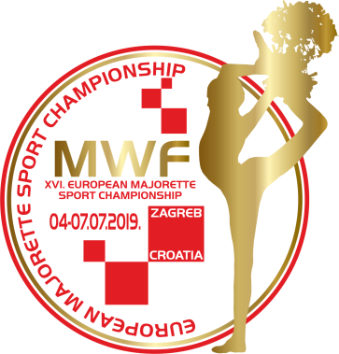
MWF-XVI. EUROPEAN MAJORETTE SPORT CHAMPIONSHIP
ZAGREB/CROATIA, 04.-07.07.2019.
T-SHIRTS-Deadline 10. 06.2019.
Send by e-mail :savez.mazoretkinja.hrvatske@gmail.com
Country:
Town:
Club:
Contact person:
Adress:
Mob:
E-mail:

T-SHIRTS | NUMBER | CALCULATION | TOTAL EUR
KIDS-number  6,8,10,12,  PRICE- 7,00 EUR |  | Number x =
WOMEN-S, M, L, XL PRICE- 8,00 EUR |  | Number x =
MEN-S, M, L, XL, XXL PRICE-8,00 EUR |  | Number x =
Total for T-SHIRTS

ON THE CHAMPIONSHIP DAYS- PRICE -KIDS-8,00 EUR
-WOMEN-10,00 EUR
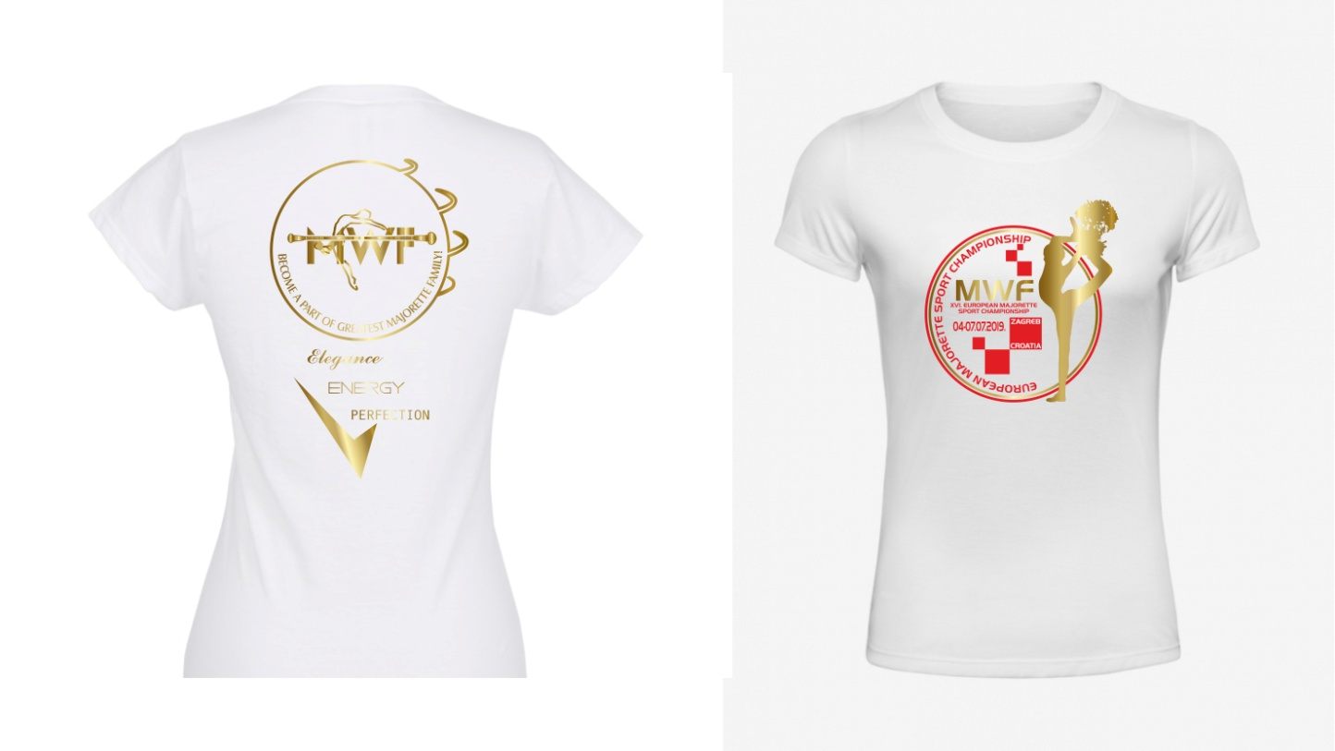
-MEN-10,00 EUR

