MWF-XVI. EUROPEAN MAJORETTE SPORT CHAMPIONSHIP
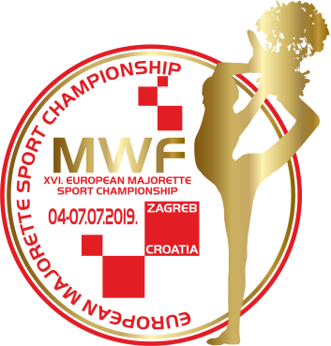
ZAGREB/CROATIA
04.-07.07.2019.
ACCOMODATION
APPLICATION FORM
DEADLINE 01.06.2019.
E-mail: majorettes.cro@gmail.com
-payment of 30% to 01.06.2019. /ALL -15.06.2019.
Adress: SAVEZ MAŽORETKINJA I POM-PON TIMOVA HRVATSKE
Bank account: RBA Raifeissen bank Austria d.d.
IBAN HR922 484 0081 101 900 360
SWIFT: RZBHHR2X
ACCOMODATION:
DATE: | Place for accomodation-  number: /1,2,3.../hostel, hotel, dorm.... | NUMBER  PERSON FOR  ACCOMODATION/price per person | TOTAL:
03.-04.07.2019.
04.-05.07.2019.
05.-06.07.2019.
05.-06.07.2019.
06.-07.07.2019.
07.-08.07.2019
ALL:

Date:_____________________ ______________________
Signature:

